**PIZZA SALES SQL QUERIES**

1. KPI’ s
2. Total Revenue -

select round(sum(TOTAL_PRICE),2) AS Sum_pizza_sales FROM PIZZA_SALES;

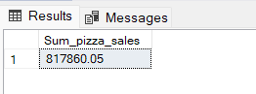

1. Average Order Value –

select round(sum(total_price)/count(distinct order_id),2) as Avg_order_value from pizza_sales;

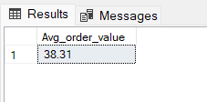

1. Total Pizzas Sold-

select sum(quantity) as Total_Quantity from pizza_sales;

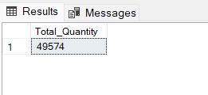

1. Total Orders-

select count(distinct order_id) as Total_Orders from pizza_sales;

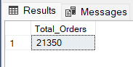

1. Average Pizzas Per Order –

select cast(cast(sum(quantity) as decimal(10,2))/cast(count(distinct order_id) as decimal(10,2)) as decimal(10,2)) as Avg_Pizzas_Per_Order from pizza_sales;

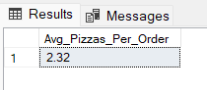

1. Chart Requirements-
2. Daily Trend for Total Orders -

select datename(dw,order_date) as Days ,count(distinct order_id) as total_orders from pizza_sales

group by datename(dw,order_date)

order by count(distinct order_id) desc ;

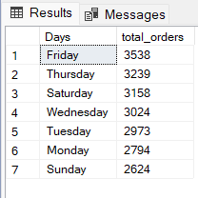

1. Hourly Trend for Total Orders –

select datepart(hour,order_time) as Hours ,count(distinct order_id) as total_order from

pizza_sales

group by datepart(hour,order_time)

order by count(distinct order_id) ;

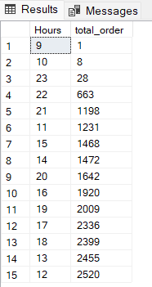

1. Percentage of Sales by Pizza Category –

* Using Subquery

select pizza_category,sum(total_price)*100/(select sum(total_price) from pizza_sales) as Percentage_Sales

from pizza_sales

group by pizza_category

order by pizza_category ;

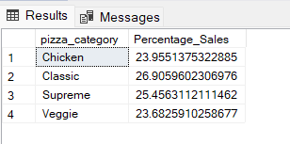

1. Percentage of Sales by Pizza Size

select pizza_size,cast(sum(total_price) *100/(select sum(total_price) from pizza_sales) as decimal(10,2)) as Percentage_Sales_by_Size

from pizza_sales

group by pizza_size

order by Percentage_Sales_by_Size;

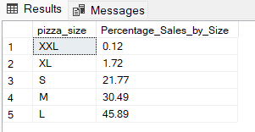

1. Total Pizzas Sold by Pizza Category

select pizza_category,sum(quantity)as Total_Sold from pizza_sales

group by pizza_category

order by Total_Sold desc;

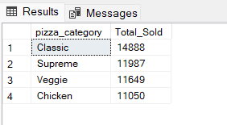

1. Top 5 Best Sellers by Total Pizzas Sold –

select top 5 pizza_name, sum(quantity) as Total_Sold from pizza_sales

group by pizza_name

order by Total_Sold desc;

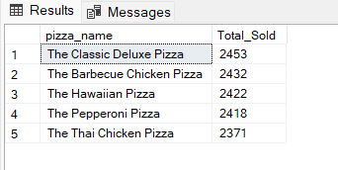

1. Bottom 5 Worst Sellers by Total Pizzas Sold –

select top 5 pizza_name, sum(quantity) as Total_Sold from pizza_sales

group by pizza_name

order by Total_Sold asc;

